Week 7 of ENL Distant Learning lessons May 18 – May 22

Monday May 18, 2020

**Objectives**: 1) I can read a nonfiction article and answer questions about it. 2) I can find the capitalization mistake and correct.

**Directions**: Read the story below and answer all the questions that follow.

A Creepy-Crawly Career

Lauren Esposito travels the world studying scorpions and spiders. Here’s what she wants you to know about these misunderstood creatures.

[APRIL 2020](https://action.scholastic.com/issues/2019-20/040120.html)

by Anna Starecheski

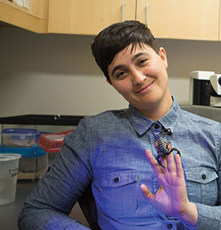

Courtesy of Kathryn Whitney/California Academy of Sciences

    If you were to see the animals on this page in real life, what would you do? Most people might run screaming. But not Lauren Esposito. She’s a biologist—a scientist who studies living things. And her specialty is arachnids, like spiders and scorpions.

    Lauren spends about half her time traveling the world looking for these creatures. Then she comes back home to write about what she found. We talked to her about working with some of the most feared animals on Earth.

**Have you always loved arachnids?**

    Not exactly. But I would look for bugs and worms in my garden as a kid. So I’ve always been drawn to creepy-crawly creatures.

**Why is it important to study arachnids?**

    They’ve been around since before the dinosaurs! They can teach us about how animals survive through time as Earth changes around them.

**What’s something that people might find surprising about your job?**

We are finding new species—or types—of arachnids all the time. I collect about 100 new species every year. Scientists have only discovered about 50 percent of the arachnids in the world!

**What traits does a good biologist need?**

You need to be curious and observant—always noticing what’s around you. And you have to be fascinated by nature!

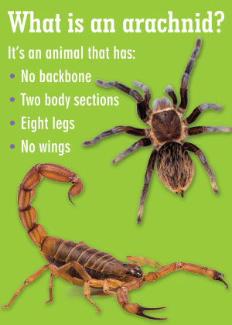

Shutterstock.com

**A lot of people are afraid of arachnids. Why is that?**

Well, the way they move is very alien to us. We’re not used to seeing things walk around on the ceiling with eight legs! Plus, there are some arachnids that are venomous—that means they have a poisonous bite or sting. So people think all arachnids can hurt them.

**What do you say to those people?**

Fewer than 1 percent of all arachnids are dangerous to humans. Most spiders can’t even bite people—their fangs are too small to get through human skin.

**Have you ever been bitten or stung?**

I was once stung by a scorpion. It felt like getting pricked by a thumbtack. I was totally fine!

Creepy Crawly Career Questions

1. How arachnids move is *alien* to us. What is another word Lauren could have used?
2. What are three traits a biologist needs?
3. Find a sentence where Lauren explains what we can learn from arachnids.

**Grammar Review: Capitalization Corrections!**

**Three Capitalization Rules**

1. Begin every sentence with a capital letter.

2. Always capitalize the word I.

3. Capitalize the first letters of proper nouns, like people’s names and names of places.

**Directions**: Each sentence below contains a capitalization mistake. Find the word that contains the mistake. On the line next to the sentence, rewrite the word correctly. We’ve done the first one for you.

1. today my sister told me she wants a pet scorpion. _________

2. “Tara,” i said, “a scorpion will sting you.” __________

3. she told me that most scorpions aren’t dangerous to humans. __________

4. “I read about them in a magazine at school,” she Explained. __________

5. “Well, pet scorpions are against the law in vermont,” I told her. __________

6. “I don’t Believe you,” Tara replied. __________

7. “why would I lie about that?” I asked her. __________

8. “You’re afraid of scorpions, and you Don’t want me to get one,” she said. __________

9. “That’s a lie!” i shouted, walking away. __________

10. To tell the truth, though, my sister is so, so Right. __________

**Tuesday and Wednesday May 19 – May 20**

**Objectives**: 1) I can read a nonfiction article to find text evidence, the central idea, and acquire new vocabulary.

**Directions**: Read the story below and answer all the questions that follow.

Day of Disaster

Nearly 2,000 years ago, a volcano destroyed the city of Pompeii. Thousands died. It was the worst disaster of the ancient world. **Now imagine that you are there.**

[APRIL 2020](https://action.scholastic.com/issues/2019-20/040120.html)

by Lauren Tarshis

 Let’s take a trip back to ancient Rome.

    It’s going to be a long trip—nearly 2,000 years. Close your eyes and imagine it. There were no computers or cars or electric lights. America wasn’t a country yet.

    Back then, much of Europe and the Middle East were part of what is known as the Roman [**Empire**](javascript:void(0);). The capital of the Roman Empire was the

city of Rome.

    It’s going to be a fascinating trip. But it will also be frightening. You’re about to witness one of the worst disasters in the history of the world.

A Summer Day

**A Summer Day**

 It’s a typical summer day in the beautiful city of Pompeii. The year is 79 a.d. The main street is packed with people—women in robes, men in long shirts called tunics. Children wear leather

sandals that slap against the hot stone streets.

    You’re surprised by how modern this city seems. It has a library, shops, and restaurants. You stop at a market with dozens of foods you can sample. Don’t you want to try roasted mice stuffed with nuts and rose petals?

    As you exit the market, you look up. And that’s when you see it—the massive mountain that stands behind the city. That’s Mount Vesuvius. Yet you don’t give it much thought. And neither do the people of

Pompeii. Why should they? It’s just a big mountain, sitting silent and still.

    Except Mount Vesuvius is not just a mountain. It is a dangerous

volcano.

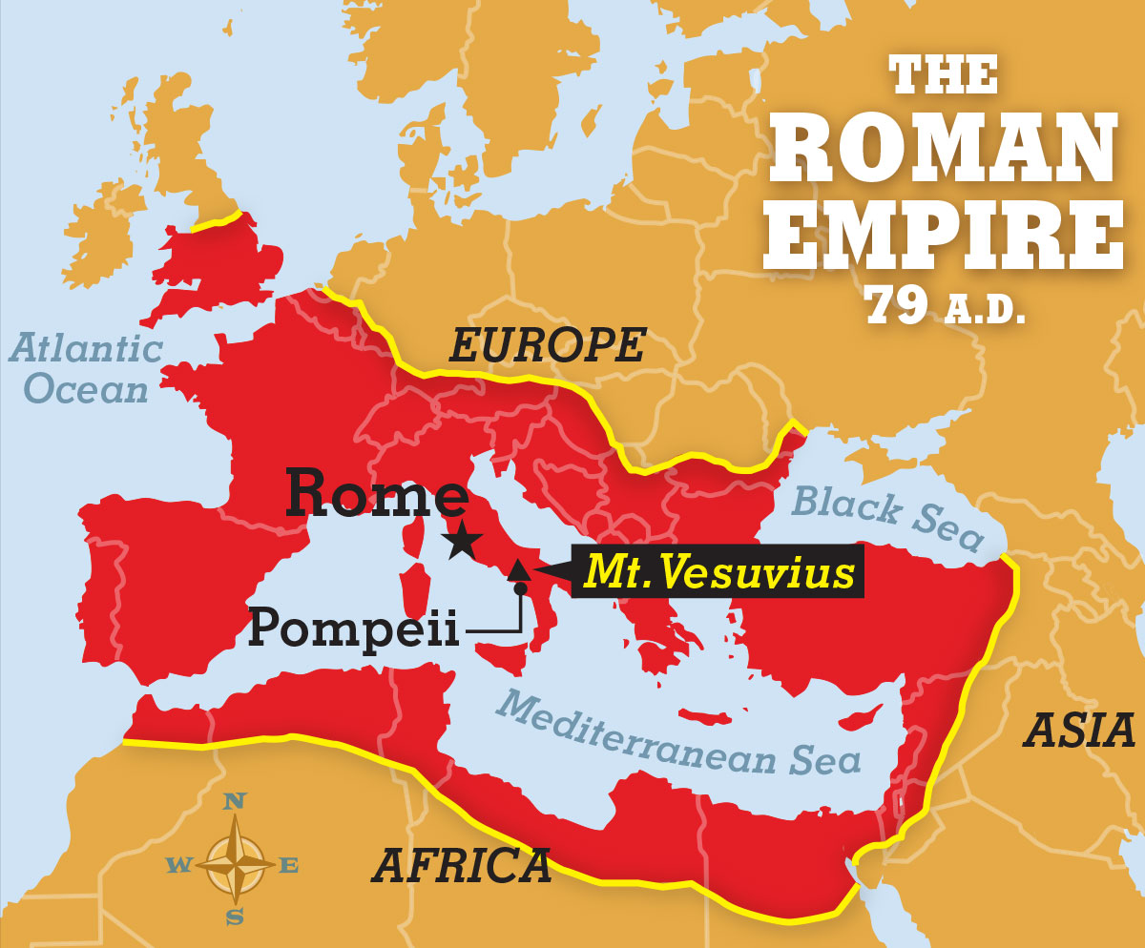

The Volcano

**The Volcano**

Vesuvius sits atop a crack in Earth’s crust. That’s the hard, rocky layer that covers the surface of our planet like the shell of an egg. The crack in the crust allows [**molten**](javascript:void(0);) rock called magma to flow up from miles below.

    A huge lake of magma boils under Vesuvius. But the people of Pompeii don’t know that. How could they? Vesuvius has been dormant—or asleep—for 1,500 years.

    But for months, magma has been rising through the center of the volcano. Pressure is building. A giant [**eruption**](javascript:void(0);) is coming.

    The people of Pompeii should have left for a safer place weeks before. If only they understood. But you do. So what are you doing standing around? Run!

A Powerful Explosion

**A Powerful Explosion**

 But actually, it’s too late. BOOM! A powerful explosion shakes the city. People fall. Horses scream. Thick, gray smoke spews from the top of Mount Vesuvius.

    Except it’s not smoke.

    The intense heat from the eruption has turned millions of tons of solid rock into super-hot foam. This foam shoots 12 miles into the sky at rocket speeds. When it hits the freezing air high above Earth, the melted rock turns into tiny pebbles called pumice.

    The pumice pours down on Pompeii with painful force. It is mixed with hot ash, which makes it difficult to breathe. You grab the hand of a little boy who has lost his family. Together, you run for your lives.

    Other people decide to stay behind, to guard their homes and businesses. They think this strange storm of ash and rock will soon end.

    They are wrong.

More Terror

**More Terror**

The sky turns black. As hours pass, the weight of the pumice causes roofs to fall in. People become trapped in their homes.

    But that’s not all.

    Suddenly, a mixture of ash and melted rock called lava rushes down the mountain. It travels at up to 180 miles an hour. When it hits Pompeii, the people left behind die instantly.

    In the weeks that follow, people search Pompeii for survivors. There are none. In fact, the entire city seems to have disappeared. Pompeii is buried under more than 10 feet of rock.

A Lost World

**A Lost World**

You survived your day in Pompeii. You are one of the lucky ones who made it out before getting crushed. But before you go home, let’s take one more trip—to Pompeii today.

    For nearly 1,700 years, Pompeii was forgotten. It was rediscovered in 1748 and has been studied by scientists ever since. The layers of pumice and ash that fell on Pompeii formed a shell over the city. This shell [**preserved**](javascript:void(0);) everything beneath it—almost like the city was frozen in time. Over the centuries, experts have dug up jewels, artwork, and statues. They even found the remains of a basket of eggs and a bowl of chicken soup.

    As you walk through the [**ruins**](javascript:void(0);) of Pompeii today, you can admire what’s left of houses, shops, and temples. And you can see Mount Vesuvius. It is silent and still. But don’t be fooled.

    Vesuvius has erupted more than 30 times since Pompeii was destroyed. The last time was in 1944. These eruptions were small. But scientists have no doubt the volcano will erupt again—with great force.

    Would you want to be there to see it?

**Directions**: Use text evidence to answer the following questions.

1. How long had Vesuvius been dormant—or asleep—before it erupted in 79 a.d.?
2. What happened to the houses when the pumice fell?
3. What happened to the people when lava flowed down the mountain?
4. What do scientists expect from Mount Vesuvius in the future?
5. What should people living near Vesuvius know?

**“Day of Disaster” Quiz**

**Directions: Circle the best answer for questions 1-6**

1. The capital of the Roman Empire was ______.

A Italy

B Pompeii

C Rome

D Vesuvius

1. Why weren’t the people of Pompeii prepared for Mount Vesuvius to erupt?

A They thought it erupted only in the winter.

B They were busy roasting mice.

C They thought an eruption wouldn’t hurt them.

D They didn’t know Mount Vesuvius was a volcano.

1. Before 79 A.D., Mount Vesuvius hadn't erupted in ______ years.

A 15

B 150

C 1,500

D 15,000

1. Why did some people decide to stay in Pompeii after the pumice started falling?

A They thought the pumice was rain.

B They wanted to guard their homes.

C They wanted to collect the pumice.

D They wanted to eat the pumice.

1. In what year was Pompeii rediscovered?

A 1492

B 1748

C 1812

D 2020

1. If you had to give “Day of Disaster” a new title, which of the following would be the best choice?

A “The Day Pompeii Disappeared”

B “Time Travel: Real or Fantasy?”

C “Ancient Chicken Soup”

D “How to Roast Mice”

**Directions for 7, 8, and 9**: Answer the following questions in two or more sentences.

1. The pumice and ash from Mount Vesuvius buried Pompeii. Explain how they also preserved it.
2. What can people learn from studying the ruins of Pompeii?
3. Describe what happened when Vesuvius erupted?

Thursday and Friday May 21 – May 22

**Objectives**: I can sequence events, acquire new vocabulary, and find causes and effects.

**Directions**: Read the article and answer the following questions.

“I Was Adopted”

Is Marcus, 15, curious about his [**biological**](javascript:void(0);) parents? Sure. But that doesn’t mean he would trade the family he has now for anything else.

by Marcus Anton Gordon, as told to Jessica Press

Marcus’s mom was also adopted. “She understands what it’s like,” he says. “We share a special bond.”

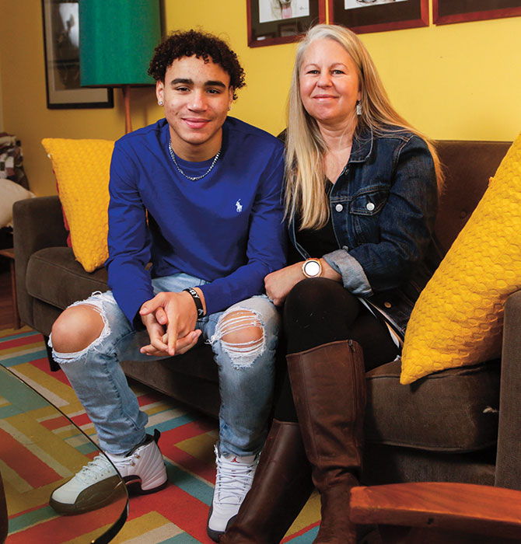My older brother and I love to watch funny movies, like *Step Brothers* and *Dumb and Dumber*.

    My dad and I cheer on the same sports teams—especially the Green Bay Packers.

    And my mom and I enjoy cooking together. She and I can talk for hours.

    We are family, in every way that any family is connected. We have common interests, and we help each other through tough times.

    The only difference?

    It just so happens that I was adopted.

**A Better Life**

A Better Life

    For my entire life, I have known the story of my adoption. I can’t remember ever *not* knowing it. I was born at a hospital in Texas, and my parents brought me home to Wisconsin. That’s where I’ve lived ever since.

    Some people think that if you’re adopted, you must be mad at your biological parents. After all, they “gave you up.” But the way I see it, my biological parents didn’t give me up. They made a major [**sacrifice**](javascript:void(0);). They wanted me to have a better life than they could provide.

    Before I was born, my mom met with my biological mother and heard her story. Both of my biological parents had had really tough lives. They didn’t have the support or money to raise me. They really wanted me to have a [**stable**](javascript:void(0);), loving family—which is what I have now.

    That’s why I think adoption is really special. My parents do too. It’s never been a secret or something I was told not to share.

Different Families

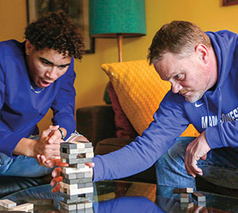

Darren Hauck/Scholastic, Inc. via AP Images

**[Game Night](https://action.scholastic.com/issues/2019-20/040120/i-was-adopted.html)** [Marcus and his dad like to watch sports and play games together.](https://action.scholastic.com/issues/2019-20/040120/i-was-adopted.html)

**Different Families**

To be honest, it would probably be hard to hide the fact that I’m adopted. That’s because I don’t really look like my parents. They’re both white. My biological mom was white too. But my biological father was black. That makes me biracial.

    Sometimes this confuses people. When they see me with one of my parents, they [**assume**](javascript:void(0);) I’m with a stepparent. I just tell them, “Nope—this is my dad,” or “This is my mom.” I know they don’t mean any harm, so it doesn’t bother me.

    Plus, I’m lucky to live in a community that’s really [**diverse**](javascript:void(0);). My friends are all different races. And these days, people have families that are formed in so many different ways. Some kids are raised by single parents or grandparents. Others have two moms or two dads.

    I can proudly say that my own family was created by adoption.

**Tracing Roots**

Tracing Roots

    I’ve never really thought about what my life would be like if I weren’t adopted. Still, there are times when I think about my biological parents. I wonder what they’re like and if I’m like them. Are they athletic? Are their appetites as big as mine?

    We’ve never heard from my biological parents. But something really exciting did happen recently. I found out that I have an older half sister living in Seattle, Washington. She and I have the same biological father.

    Once we found her online, my mom reached out to her mom. They were so happy to hear from us. We started texting right away. Now, my mom and I are flying out to see them in a few weeks.

    I feel nervous, but mostly excited. I finally get to meet someone who shares my biological roots. I already know my half sister likes sports and listens to rap—just like I do. I can’t wait to find out what else we might have in common.

“Real” Parents

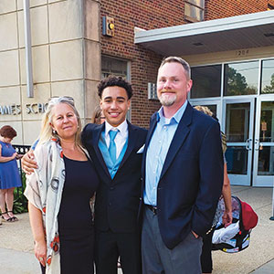

Courtesy of family

**[Happy Family](https://action.scholastic.com/issues/2019-20/040120/i-was-adopted.html)** [Marcus poses with his mom and dad after middle school graduation.](https://action.scholastic.com/issues/2019-20/040120/i-was-adopted.html)

**Real Parents**

 Sure, I may be curious about where I came from. But there is never a moment when I don’t think of my mom, dad, and brother as my family.

    Sometimes, people will ask me questions about my “real parents.” When they do, I explain that my real parents are the ones who have raised me these past 15 years.

    They’re the ones I live with and the ones I love. I believe that’s what makes a group of people a family.

Follow up Questions

Directions: Use the text to answer the following questions from the article.

1. Is Marcus curious about his biological parents?
2. What biological relative is Marcus going to see soon?
3. Did Marcus recently learn that he was adopted, or has he always known it?
4. Who does Marcus say he cooks with: his mom or his brother?
5. Is Marcus angry at his biological parents, or does he think they made a sacrifice by putting him up for adoption?
6. Is Marcus proud of being adopted, or is he embarrassed?
7. Does Marcus look like his parents, or does he look different?
8. Who does Marcus consider his “real” parents: the ones who raised him or his biological parents?
9. What does Marcus have in common with his mom?
10. When Marcus thinks about his biological parents, what questions does he have about them?